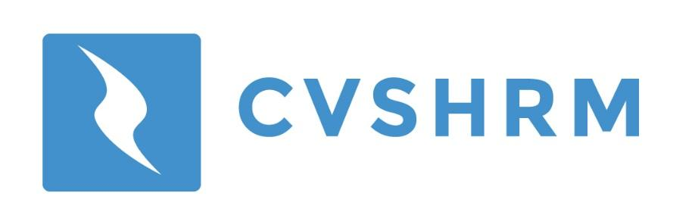
Guest Voucher Form
What is it?
Use this form to bring a guest to an upcoming meeting
Free of Charge!

We want to spread the word about CVSHRM!
You can bring up to 2 guests per year free of charge. Just complete this form and email to tammyg@mylsb.com the Friday prior to the meeting.

If you have questions, Please contact Patrick Moran at 319-292-2842, or pmoran@poscorp.com

Guest Information
Name:______________________________ Company:_________________________
Phone:___________________ Email:___________________________________________

Referring CVSHRM Member Name: ___________________________________________

