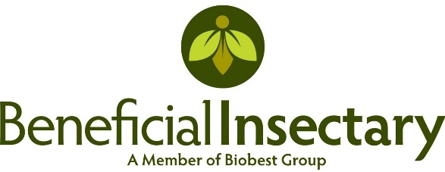

JOB TITLE: HR Coordinator
FLSA Status: Non-Exempt
Anticipated range: $25 - $30.00, depending on experience
Location: HR Department
Reports to: HR Manager

POSITION SUMMARY
The HR Coordinator provides comprehensive support to the HR department in the areas of payroll, recruiting, onboarding, benefits, compliance, training, and employee relations. This position is responsible for end-to-end weekly and bi-weekly payroll processing across multiple states while also contributing to the design and implementation of HR policies, programs, and training initiatives.

This is not solely a transactional role; the HR Coordinator is expected to apply knowledge of HR best practices and employment law to support compliance, improve processes, and contribute to a positive employee experience.

ESSENTIAL DUTIES AND RESPONSIBILITIES
Payroll & HRIS (Core Function)
- Lead full-cycle weekly and bi-weekly payroll processing for multistate employees (non-exempt and exempt).
- Validate timesheets, overtime, differentials, premiums, deductions, reimbursements, and benefit contributions.
- Ensure compliance with California and other state wage and hour laws (meal/rest premiums, final pay, sick leave, OT/doubletime).
- Reconcile payroll registers, resolve discrepancies, and coordinate with Finance/Accounting for funding and reporting.
- Maintain payroll and HRIS data accuracy; partner on payroll-related policy development and compliance updates.
HR Policy, Compliance & Process Improvement
- Assist in the creation, implementation, and communication of HR policies and procedures.
- Ensure HR practices remain compliant with federal, state, and local employment laws.
- Identify opportunities to streamline payroll, onboarding, and compliance processes for efficiency and accuracy.
- Support HR audits and recommend process or policy adjustments to strengthen compliance.
Talent Acquisition & Onboarding
- Coordinate recruiting activities including postings, scheduling, and candidate communications.
- Contribute to developing structured onboarding programs that reinforce company culture and compliance.
- Partner with HR Manager to enhance candidate and new hire experience.
Training & Development
- Coordinate training assignments and track completion of compliance and development programs.
- Support the design and rollout of employee training initiatives (e.g., harassment prevention, safety, HR systems).
- Provide reporting and feedback to leadership on training compliance and effectiveness.

Benefits & Leave Administration
- Administer benefits programs including enrollment, changes, and terminations.
- Support employees with leave requests (FMLA, CFRA, PDL, PSL, etc.) ensuring compliance with state/federal laws.
- Partner with HR Manager to evaluate and update leave and benefit policies as needed.
Employee Support & Reporting
- Serve as a point of contact for employees on payroll, benefits, and HR policy questions.
- Provide accurate reporting and analytics to HR leadership to inform decisions.
- Contribute to initiatives that enhance employee engagement and retention.
- Additional duties as assigned

QUALIFICATIONS AND REQUIREMENTS
- Associate’s or Bachelor’s degree in Human Resources, Business Administration, or related field preferred.
- 2–3 years of HR or payroll experience required; multistate payroll experience strongly preferred.
- Proficiency with HRIS and payroll systems (Paylocity experience highly preferred).
- Knowledge of California and federal wage and hour compliance required.
- Strong organizational and analytical skills; ability to identify and recommend process improvements.
- Excellent communication and interpersonal skills with a collaborative, team-oriented mindset.
- Ability to maintain confidentiality with sensitive employee data.
- Proficiency in Microsoft Office Suite (Excel, Word, Outlook).
WORK ENVIRONMENT & PHYSICAL REQUIREMENTS
- Primarily office environment with extended periods of computer work.
- Frequent sitting, with occasional standing, bending, and lifting up to 20 pounds.
- Fast-paced environment with frequent interruptions and shifting priorities.
Send resume to:
Sherry Rynearson, HR Manager
Sherry.Rynearson@insectary.com

