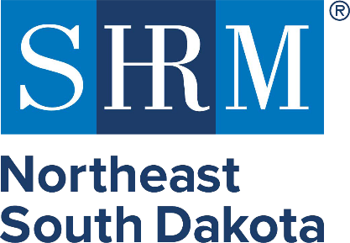

Support the Future of Leadership in Northeast South Dakota!

Sponsor NESD SHRM — Empower Professionals, Elevate Our Community
The Northeast South Dakota Society for Human Resource Management (NESD SHRM) is committed to delivering high-quality professional development, networking, and leadership education for HR professionals and business leaders across our region.

With your support, we can continue offering: Engaging, expert speakers, quality meals at chapter meetings, educational programs that strengthen our workforce and networking opportunities that build stronger organizations.

Meeting Sponsor — $1,000 (price includes speaker and meal)
- Logo on meeting chapter marketing materials and website
- 5 minutes to speak at meeting
- Opportunity to introduce a speaker (provide gift) or welcome attendees

Platinum Sponsor — $1,000
- Logo on all chapter marketing materials and website
- Recognition at every chapter meeting
- Opportunity to introduce a speaker or welcome attendees
- Complementary 1 year SHRM membership
- Social media recognition throughout the year

Gold Sponsor — $750
- Logo on chapter website and select marketing materials
- Recognition at chapter meetings
- Complementary meeting registrations (up to 3)
- Social media recognition

Silver Sponsor — $500
- Logo on chapter website
- Recognition at sponsored meetings
- Complementary meeting registrations (up to 2)
- Social media recognition

Bronze Sponsor — $250
- Recognition at sponsored meetings
- Logo on chapter website
- Social media recognition

Ready to Partner with Us?
Contact: Marisa Sobeski
Email: marisa.sobeski@millerwelds.com
Phone: 605-880-7036

Thank you for partnering with NESD SHRM to make professional development accessible, engaging, and impactful!

